Intelligent Rapid Shuttle (IRS)

User Guide

1. Download pre-built virtual machine from <http://bit.ly/iss-vm>
2. Start iss-vm
3. Open terminal in iss-vm
4. git clone <https://github.com/aivoyagers/IRS-RS-2019-01-19-IS1PT-GRP-aiVoyagers-irs-Intelligent-Rapid-Shuttle.git>
5. Import the project to KIE
6. Build and Deploy to the execution server of KIE workbench
7. Copy the intelligentrapidshuttle-0.0.1-SNAPSHOT.war file to the JBOSS server by issuing the following command:

cp intelligentrapidshuttle-0.0.1-SNAPSHOT.war /home/iss-user/iss-vm-program/is-intelligent-reasoning-systems/jboss/jbpm-server-7.12.0.Final-dist/standalone/deployments/

1. Go to web browser and key in the url:

<http://localhost:8080/intelligentrapidshuttle-0.0.1-SNAPSHOT/IRSIndex.jsp>

1. Choose ‘DataSet1’ as the input and click ‘Submit’. All the student locations would be shown in red. The schools will be shown as yellow stars while the vehicle locations would be shown in black.

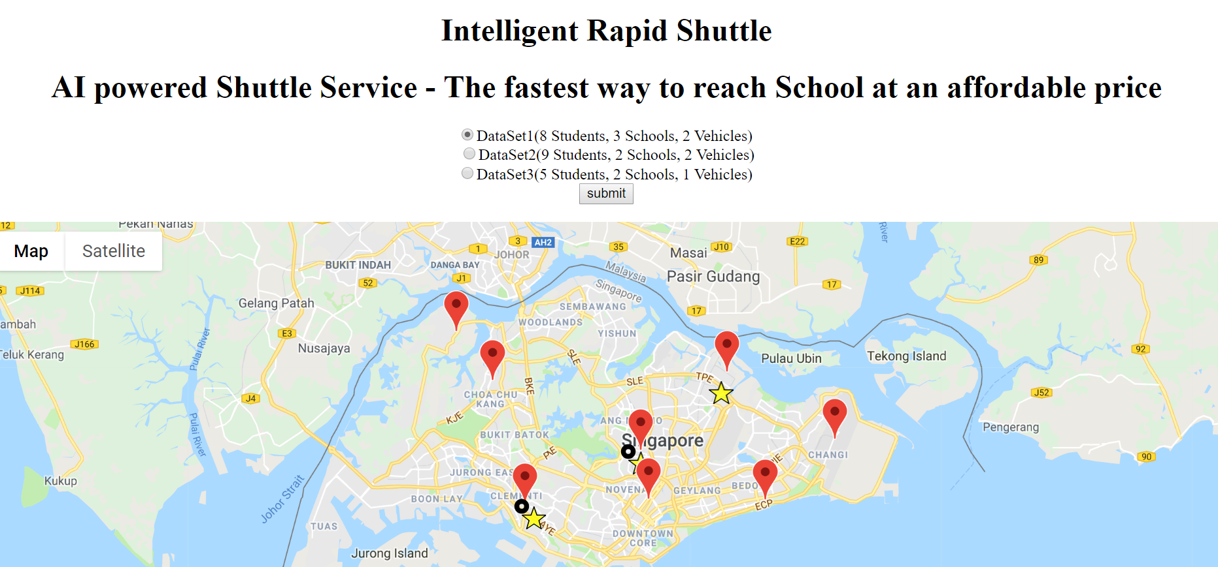

1. Click on the ‘Solve Shuttle planning problem’.

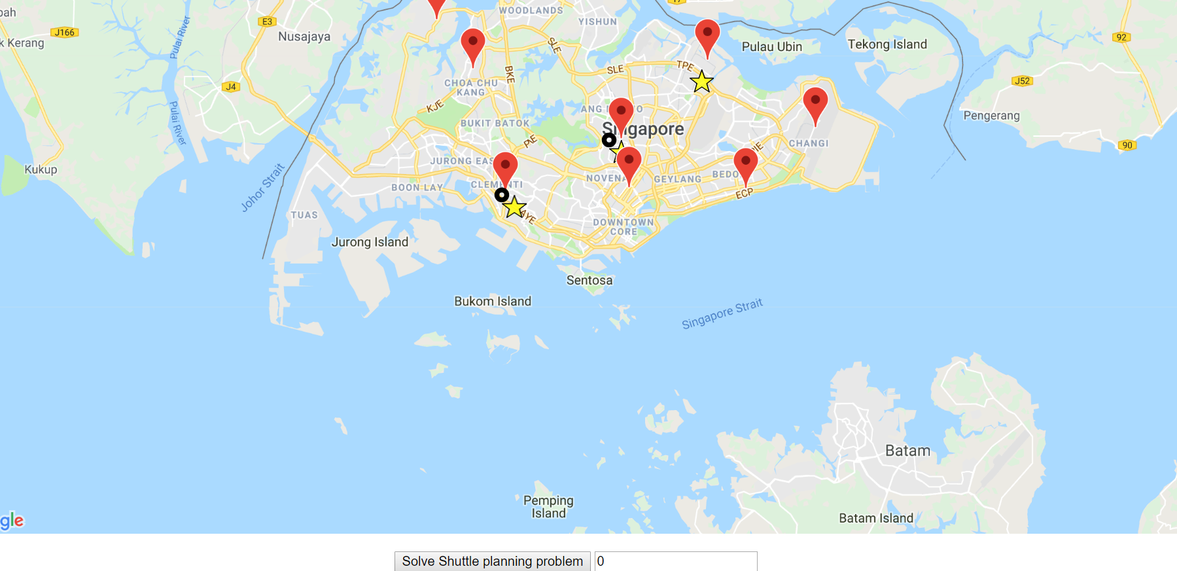

1. The output of the above selection can be seen as below where the shortest route is plotted in the map for the two vehicles corresponding to the 8 students and 3 schools.

